Step : 1

Download Apache Web Server and start the server ..

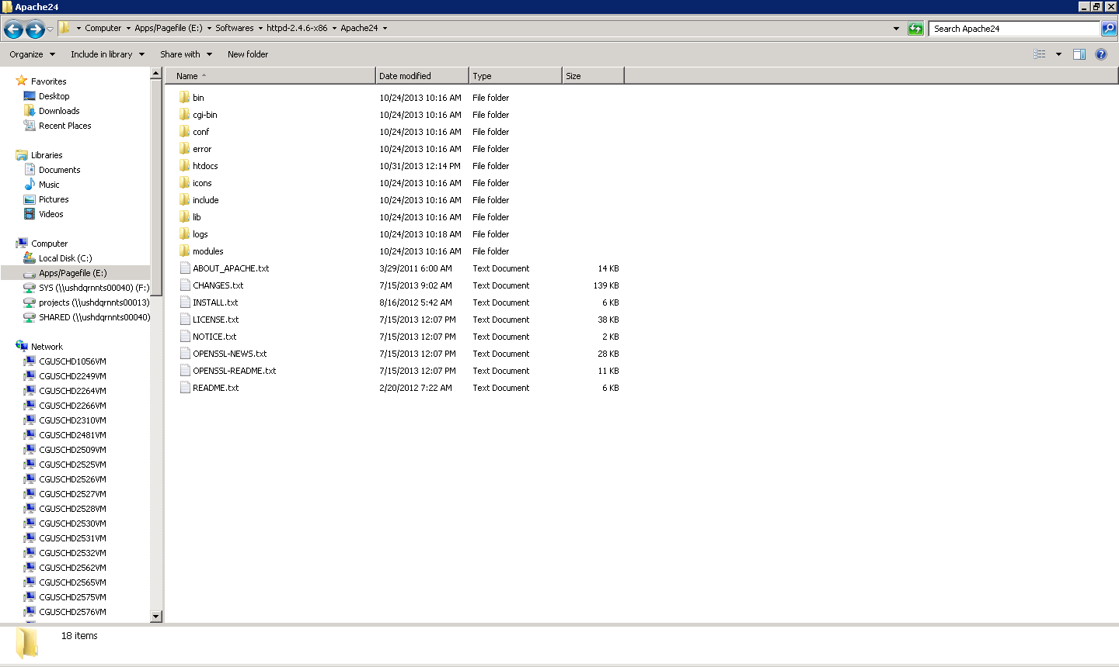

Step 2: Download extjs and extract to htdocs/extjs of Apache server ….

<http://www.sencha.com/products/extjs/download/ext-js-4.2.1/2281>

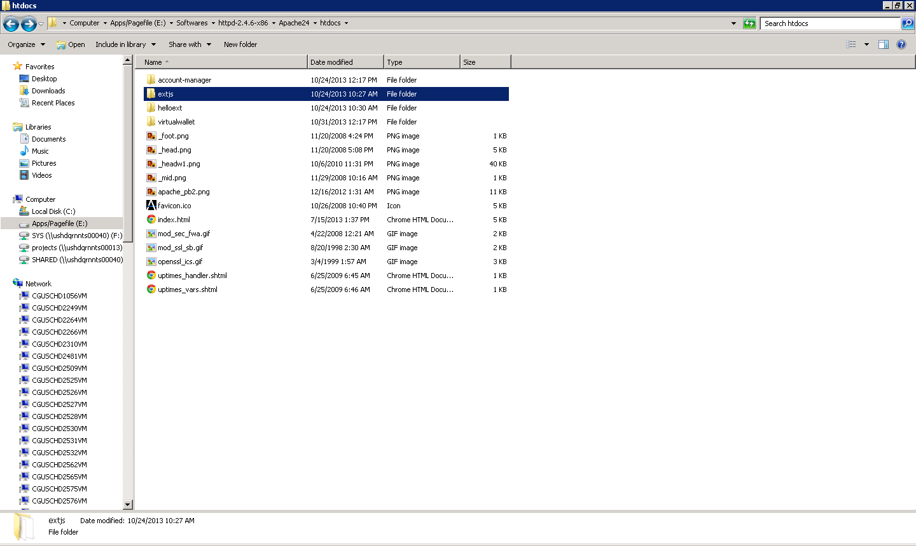

Step 3: Check extjs is installed correctly…

<http://localhost/extjs/examples/index.html>

Step 4: Extract the helloext to htdocs and request below url…

<http://localhost/helloext/index.html>